MIMO Demo Configuration Guide
This document details the hardware and software configuration for a 2x2 MIMO demo system. The system consists of 2 M9381A PXI VSGs and 2 M9391A PXI VSAs in a single M9018A PXI chassis, with M9036A controller.

Hardware Configuration
The system is configured as follows:
M9381A #1:
- M9311A in slot 2
- M9310A in slot 4
- M9301A in slot 5
M9391A #1:
- M9301A in slot 7
- M9350A in slot 8
- M9214A in slot 9
M9300A in slot 10
M9391A #2:
- M9301A in slot 11
- M9350A in slot 12
- M9214A in slot 13
M9381A #2:
- M9311A in slot 15
- M9310A in slot 17
- M9301A in slot 18
The normal cables should be installed on the instruments. Additionally, the 100 MHz reference cables from M9300A to the M9301A synthesizers should all be equal length. The M9300A frequency reference module must be installed in slot 10 for proper operation. A trigger cable from M9311A in slot 2, Trig 2, to M9214A in slot 9, Trig 1 should be connected to improve demo operation for loopback demos.
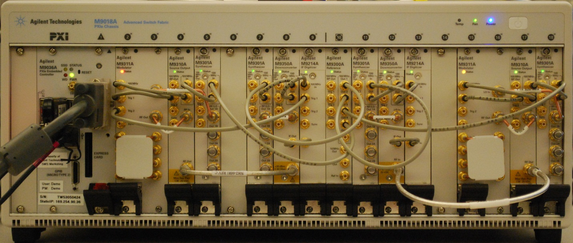
2x2 configuration

Software Configuration

The software should be installed in the following order:
- 89600 version 16.2 or greater
- M9391 version 1.1.113.0 or later
- M938x version 1.3.131 or greater.
- M9018A version 1.3.443.1 or greater.
- Run self tests and verify correct FPGA bits on all 4 instruments using SFP's. Do this one at a time:

- Run M9381A SFP and connect to VSG #1 and the M9300A.
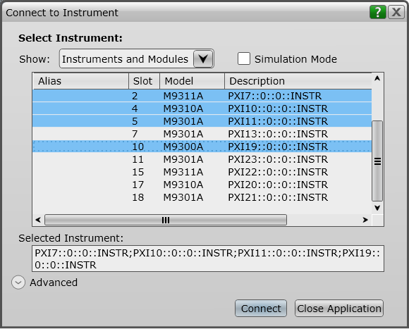

- Run self test
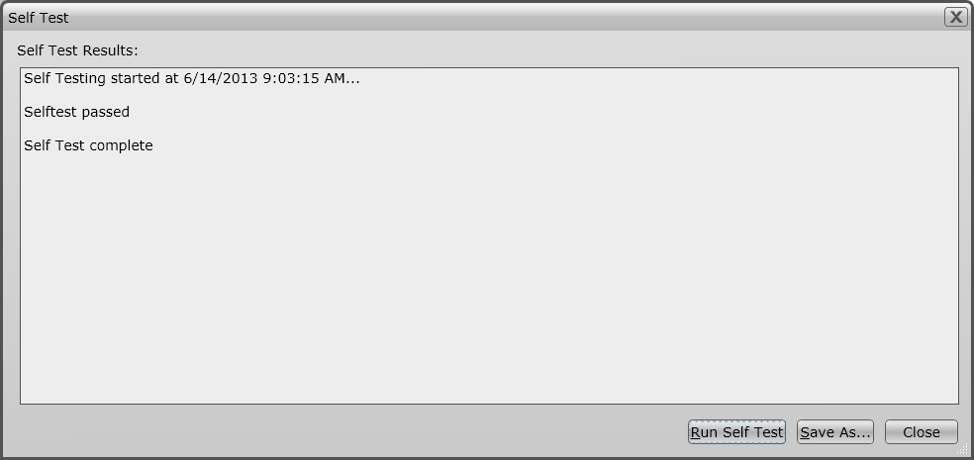

- Check firmware and update if necessary
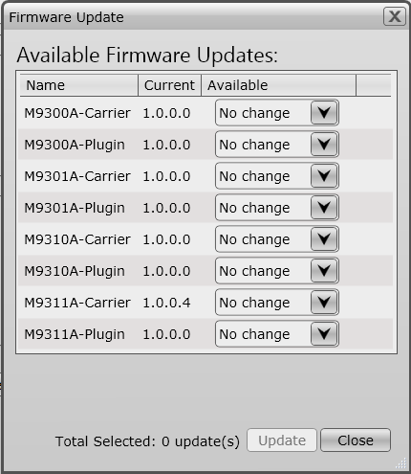

- Quit the SFP (click the X in the corner of the window)

- Connect to VSG #2 and the M9300A.
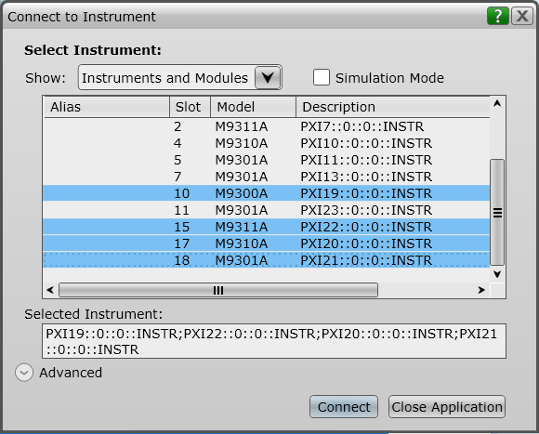

- Run self test

- Check firmware and update if necessary

- Quit the SFP

- Run the M9391A SFP, connect to VSA #1 and the M9300A
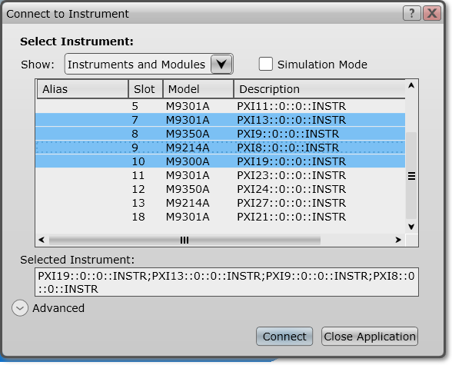

- Run self test

- Check firmware and update if necessary

- Quit the SFP

- Connect to VSA #2 and the M9300A

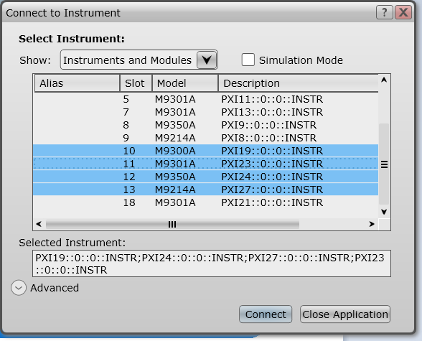
- Run self test

- Check firmware and update if necessary

- Create aliases for instruments

- Connect to VSG #1. Do not include the M9300A.
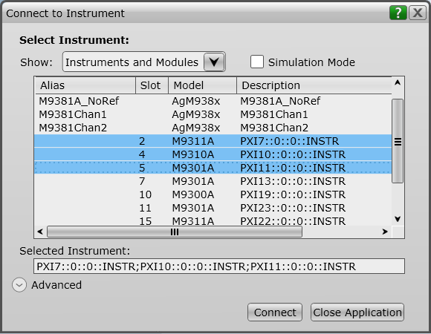

- Save Connection named M9381Chan1
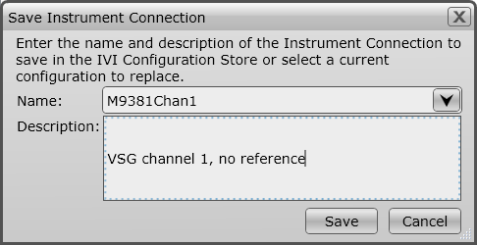

- Connect to VSG #2. Do not include the M9300A.
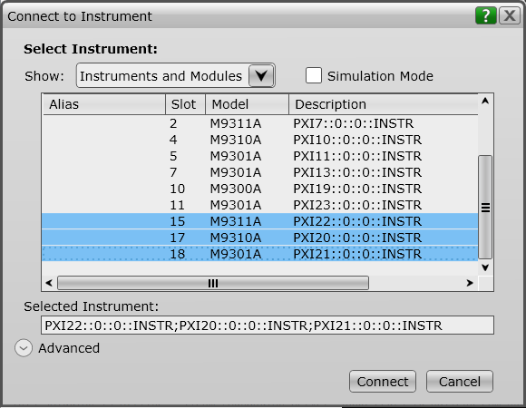
- Save Connection named M9381Chan2

- Run M9300A SFP and connect to the M9300A.

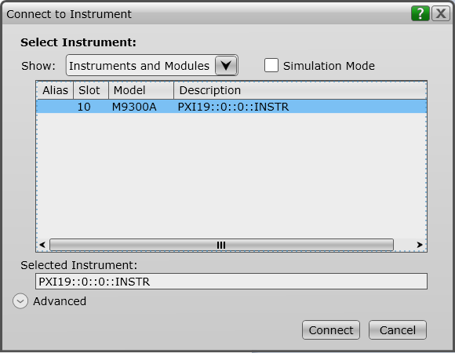

- Save connection named M9300
- Add a VISA Alias to the M9018A chassis called “M9018”
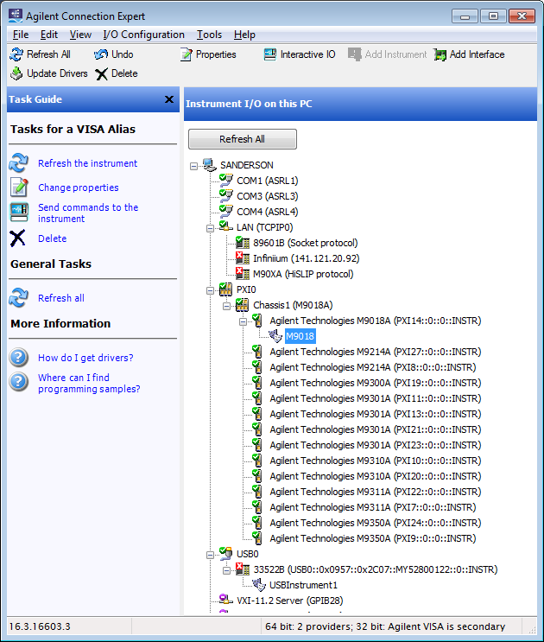

- Create 2-channel M9391A configuration in 89600. Include the M9300 module in channel 1, but not in channel 2. See below.
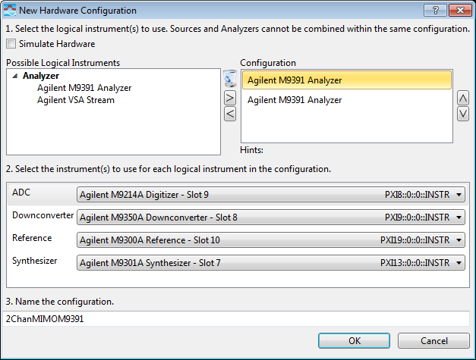
Channel 1 configuration

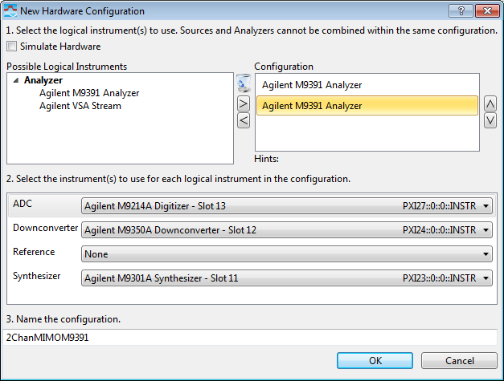
Channel 2 configuration

- Connect to the new hardware configuration.
- Exit the 89600 VSA software to ensure all settings are saved.

- Copy the MIMO VSG Demo directory on to the desktop. This includes the MIMO Demo tool, waveforms, Signal Studio settings files, 89600 recording files and 89600 setup files.

At this point your system should be properly configured. Proceed to the demo guide for instructions on how to use the demo tool and 89600 VSA with the MIMO PXI VSG and VSA.

